Practical-5
#include <WiFi.h>
#include "DHT.h"
#include "HTTPClient.h"
// ====== WiFi Credentials ======
const char* ssid = "ENTC04"; // your WiFi name
const char* password = "$inhgad@2122"; // your WiFi password
// ====== ThingSpeak ======
String apiKey = "5UP8HD2GGD9E0CWG"; // your ThingSpeak Write API key
const char* server = "http://api.thingspeak.com/update";
// ====== DHT11 Setup ======
#define DHTPIN 4 // GPIO pin where DHT11 data pin is connected
#define DHTTYPE DHT11
DHT dht(DHTPIN, DHTTYPE);
void setup() {
Serial.begin(115200);
WiFi.begin(ssid, password);
Serial.print("Connecting to WiFi");
while (WiFi.status() != WL_CONNECTED) {
delay(500);
Serial.print(".");
}
Serial.println("\n✅ Connected to WiFi");

dht.begin();
}
void loop() {
float h = dht.readHumidity();
float t = dht.readTemperature(); // Celsius
if (isnan(h) || isnan(t)) {
Serial.println("❌ Failed to read from DHT11 sensor!");
return;
}
Serial.print("🌡 Temperature: ");
Serial.print(t);
Serial.print(" °C 💧 Humidity: ");
Serial.print(h);
Serial.println(" %");
if (WiFi.status() == WL_CONNECTED) {
HTTPClient http;
String url = String(server) + "?api_key=" + apiKey + "&field1=" + String(t) + "&field2=" + String(h);
http.begin(url);
int httpCode = http.GET();
if (httpCode > 0) {
Serial.println("✅ Data sent to ThingSpeak successfully!");
} else {
Serial.println("❌ Error sending data");
}
http.end();
} else {
Serial.println("⚠ WiFi disconnected! Trying to reconnect...");
WiFi.begin(ssid, password);
}
delay(20000); // ThingSpeak minimum update interval = 15 seconds
}
OUTPUT:
Serial Monitor-

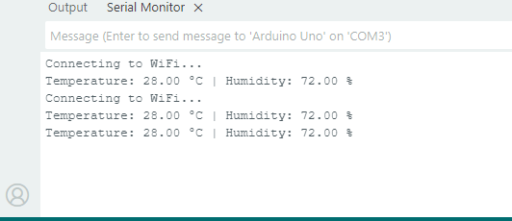

ThingSpeak graph:

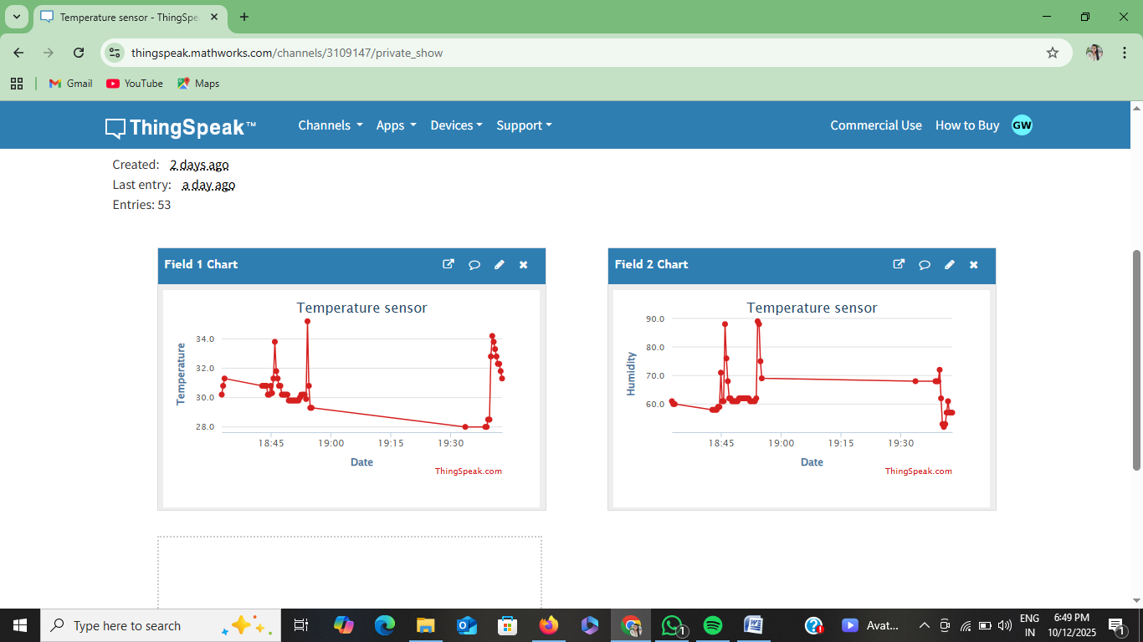

Hardware Output:
